 | Monday | Tuesday | Wednesday | Thursday | Friday
Week 1  04/11/24  25/11/24  16/12/24  20/01/25  10/02/25  10/03/25  31/03/25 | Beef Bolognese  Broccoli  Garlic Bread  Quorn Mince Bolognese  Cold Option  Egg or Cheese Sandwich 50/50 Bread | 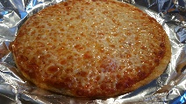  Mario’s Margarita  Pizza (2,7,)  Garden Salad  Potato Croquette  Cold Option  Tuna or Cheese Sandwich on 50/50 Bread | Roast Pork  Baby Potatoes  Vegetable Medley  Carrot and Bean cutlet  Cold Option  Ham or Cheese on Baguette | Chicken Curry W/Rice  Naan Bread  Carrots and Beans  Quorn Chicken Curry  Cold Option  Chicken or Cheese Sandwich on 50/50 Bread | Fillet of Fish (2,5)  Chips  Baked Beans  Veggie Goujons  Cold Option  Tuna or Cheese Sandwich on 50/50 Bread
Desserts | Apple Crumble W/Custard | Jam Sponge (2,4,7) | Ice Cream Sundae (7) | Flap Jack (2,7) | Shortbread
Week 2  11/11/24  02/12/24  06/01/25  27/01/25  24/02/25  17/03/25 | Chicken Goujon Wrap (2,7,13)  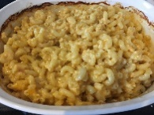  vegetable Sticks  This Photo by Unknown Author is licensed under CC BY-NC-ND  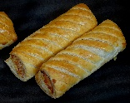  Potato Waffles  Quorn Fillet Wrap  Cold Option  Cheese or Egg sandwich on 50/50 Bread | Shepherds Pie  Bread Roll  Vegetable Medley  Vegetable Pie  Cold Option  Ham or Cheese Sandwich on 50/50 Bread | Roast Beef  Roast Potatoes  Cauliflower and Broccoli  Yorkshire Pudding  Roast Quorn Cutlet  Cold Option  Beef or Cheese  Baguette | Vegetable Pasta (2,4,7)  Fresh Salad  Garlic Bread  Cold Option  Cheese or Tuna on Pita Bread | Fish fingers (2,5)  Chips  Peas  Quorn fingers  Cold Option  Tuna or Cheese Sandwich on 50/50 Bread
Desserts | Ginger Cake W/Custard (2,4,7) | Rice Crispy Cake(7) | Raspberry Yogurt (7) | Carrot Cake | Lemon Sponge (2,4,7)
Week 3  18/11/24  09/12/24  13/01/25  03/02/25  03/03/25  24/03/25 | Cheese Quesadilla  Potato waffles  Salad  Cold Option  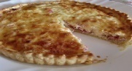  Egg or Cheese Sandwich on 50/50 Bread | Beef Lasagne  Garlic Bread  Fresh Salad  Quorn mince Lasagne (2,4,7)  Cold Option  Beef or Cheese on Pita Bread | Roast Turkey with Sage and Onion Stuffing  Mashed Potatoes  Carrots and Green Beans  Roast Quorn Chicken  Cold Option  Chicken or Cheese Baguette | Sausage serve w/  mashed Potatoes  and Baked Beans  Vegetarian sausage  Cold Option  Ham or Cheese Wrap | 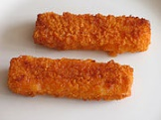  Crunchy Fish  Cake (2,5)  Baked Beans  Chips  Veggie patty  Cold Option  Tuna Or Cheese Sandwich on 50/50 Bread
Desserts | Strawberry Angel Delight (7) | Chocolate Cake (2,4,7) | Peach Crumble W/Ice Cream | Pineapple Upside Down Cake W/Custard (2,4,7) | Chocolate Chip Cookies (2)


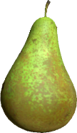

Cold Options are served with Fruit, Savoury snacks, vegetable sticks and Desserts of the day.

Autumn Menu
Allergen Key: 1) Celery 2) Cereal Containing Gluten 3) Crustaceans 4) Eggs 5) Fish 6) Lupin 7) Milk 8) Mollusc 9) Mustard 10) Nuts 11) Peanuts 12) Sesame seed 13) Soya 14) Sulphur Dioxide
Fresh Fruit daily

