 | Monday | Tuesday | Wednesday | Thursday | Friday
Week 1  21/04/25 15/09/25  12/05/25 06/10/25  09/06/25  30/06/25  21/07/25 | Beef and Onion pie (2,1,15)  Mashed potatoes (7)  Peas | 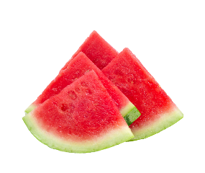  Vegetable Pasta Bake  Broccoli (2,7)  Garlic Bread (2,13) | Roast Gammon (2,13)  Baby new Potatoes  Broccoli and Carrots | Chicken Korma with Rice (7)  Poppadom  Vegetable Medley | Fillet of Fish (2,5)  Chips  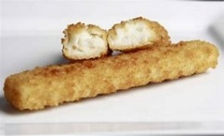  Baked Beans
Veggie Option | Veggie Pie (2,7) |  | Quorn Roast 4,7) | Potato and Veg Korma (7) | Veggie Goujons(2,7)
Sandwich Option | Ham or Cheese Sandwich 50/50 Bread (2,7) | Tuna or Cheese Sandwich on 50/50 bread (2,5,7) | Ham or Cheese on soft Bap  (2,7) | Chicken or Tuna  Sandwich on 50/50 Bread (2,5) | Tuna or Cheese Sandwich on 50/50 Bread (2,5)
Jacket Potato | Baked beans, Tuna mayo (4,5) or Cheese (7) | Baked beans, Tuna mayo (4,5) or Cheese (7) | Baked beans, Tuna mayo (4,5) or Cheese (7) | Baked beans, Tuna mayo (4,5) or Cheese (7) | Baked beans, Tuna mayo (4,5) or Cheese (7)
Dessert | Arctic Roll (2,7) | Iced Bun (2,4,7) | Raspberry yogurt (7) | Carrot Cake (2,7) | Shortbread (2)
Week 2  28/04/25 01/09/25  19/05/25 22/09/25  16/06/25 13/10/25  07/07/25 | Sausage Rolls (2,7,13)  Spaghetti hoops  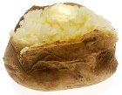  Potato waffles  This Photo by Unknown Author is licensed under CC BY-SA | Chicken Nuggets (2)  Salad  Potato Wedges | Roast Beef with gravy (2,13)  Roast Potatoes  Cauliflower and Broccoli  Yorkshire pudding | Cheesy Macaroni (2,7) Broccoli  Garlic Bread (2,7.13) | Fish Fingers (2,5)  Chips  Baked Beans
Veggie Option | Cheese and Onion Roll (2,7) | Quorn Chicken Schnitzel (2,9,13,14) | Roast Quorn Cutlet (2,9,13,14) |  | Veggie Fingers (2,7)
Sandwich Option | Ham or Egg sandwich on 50/50 Bread (2,7) | Tuna or Cheese Sandwich on 50/50 Bread ( 2,5,7) | Ham or Cheese on soft roll (2,7) | Egg or Tuna on soft roll (2,4,5) | Tuna or Cheese Sandwich on 50/50 Bread (2,5,7)
Jacket Potato | Baked beans, Tuna mayo (4,5) or Cheese (7) | Baked beans, Tuna mayo (4,5) or Cheese (7) | Baked beans, Tuna mayo (4,5) or Cheese (7) | Baked beans, Tuna mayo (4,5) or Cheese (7) | Baked beans, Tuna mayo (4,5) or Cheese (7)
Dessert | Iced Sprinkled Cake (2,4,7) | Jelly and Ice Cream (7) | Chocolate Chip Shortbread (2) | Flap Jack (2) | Lemon Drizzle Cake (2,4,7)
Week 3  05/05/25 29/09/25  02/06/25 20/10/25  23/06/25  14/07/25  08/09/25 | Beef Meatballs in Homemade Tomato sauce with pasta (2,7,13) | Hot dog in a roll (2,14)  potato wedges and fresh salad | Roast Turkey with Sage and Onion Stuffing (2,7,13))  Mashed Potatoes  Carrots and Green beans | 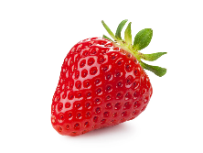  Mamas Homemade Pizza (2,4,7)  Potato Croquettes (2)  Fresh salad | 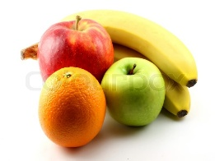  Breaded Fish  Cake (2,5)  Peas  Chips
Veggie Option | Veggie Meatballs (1,13,15,16) | Veggie Dog (2,13,14) | Roast Quorn Chicken (4,7) |  | Veggie Cake (2,7)
Sandwich Option | Egg or Ham Sandwich on 50/50 Bread (2,4) | Ham or Cheese on Soft Roll  (2,7) | Chicken or Cheese on Soft Roll (2,7) | Tuna or Cheese Wrap (2,5,7) | Tuna Or Cheese Sandwich on 50/50 Bread (2,5,7)
Jacket Potato | Baked beans, Tuna mayo (4,5) or Cheese (7) | Baked beans, Tuna mayo (4,5) or Cheese (7) | Baked beans, Tuna mayo (4,5) or Cheese (7) | Baked beans, Tuna mayo (4,5) or Cheese (7) | Baked beans, Tuna mayo (4,5) or Cheese (7)
Dessert | Strawberry Mousse (7) | Chocolate Cake with Creme  (2,4,7) | Melon Medley | Raspberry Cheesecake (2,4,7) | Orange Cake (2,4,7)


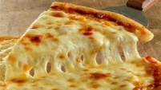
Spring / Summer Menu
Spring Menu

The Sandwich options are served with Fruit, vegetable sticks and Desserts of the day. Fresh fruit daily. Allergen Key: 1) Celery, 2) Cereal Containing Gluten, 3) Crustaceans, 4) Eggs, 5) Fish, 6) Lupin, 7) Milk, 8) Mollusc, 9) Mustard, 10) Nuts, 11) Peanuts, 12) Sesame seeds, 13) Soya, 14) Sulphur Dioxide 15) Barley, 16) Oats.
Spring Menu

