 | Monday | Tuesday | Wednesday | Thursday | Friday
Week 1  03/11/25  24/11/25  15/12/25 | Beef Spaghetti with Homemade Tomato Sauce  Garlic Bread (2)  Fresh Salad | 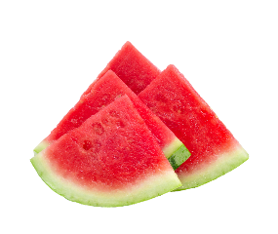  Cream of Tomato Soup (7) served with  Homemade Bread | Roast Gammon (2,13)  Baby New Potatoes  Broccoli and Carrots | Chicken Korma served with Rice (2,4,7)  Naan Bread  Green Beans | Fillet of Fish (2,5)  Chips  Baked Beans
Veggie Option | Vegetarian Spaghetti (2,7) |  | Carrot & Bean Cutlet (4,7) | Potato Curry (7) | Veggie Goujons (2,7)
Sandwich Option | Ham or Cheese sandwich 50/50 Bread (2, 7) | Tuna or Cheese Sandwich on 50/50 Bread (2, 5, 7) | Ham or Cheese on Soft Bap (2, 7) | Turkey or Cheese Sandwich on 50/50 Bread (2, 5) | Tuna or Cheese Sandwich on 50/50 Bread (2, 5)
Jacket Potato | Baked Beans, Tuna Mayo  (4,5) or Cheese (7) | Baked Beans, Tuna Mayo  (4,5) or Cheese (7) | Baked Beans, Tuna Mayo (4,5) or Cheese (7) | Baked Beans, Tuna Mayo  (4,5) or Cheese (7) | Baked Beans, Tuna Mayo (4,5) or Cheese (7)
essert | Jam Sponge (2,7) | Apple Crumble with Custard (2,4,7) | Raspberry Yogurt (7) | Ginger Cake with Custard (7) | Treacle Cake (2,4,7)
Week 2  10/11/25  01/12/25 | Baked Sausage (2,7,13)  Spaghetti Hoops  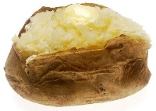  Creamy Mashed Potatoes  This Photo by Unknown Author is licensed under CC BY-SA | Chicken Pasta Bake  (2, 7)  Fresh Salad | Roast Beef with Gravy (2,13)  Roast Potatoes  Cauliflower, Broccoli &  Yorkshire Pudding | Vegetable Pizza (2,4,7)  Potato Waffles  Fresh Salad | Fish Fingers (2,5)  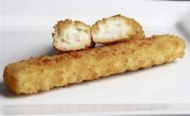  Chips  Baked Beans
Veggie Option | Vegetarian Sausage (2,7) | Vegetable Pasta Bake (2,9,13,14) | Roast Quorn Cutlet (2,9,13,14) |  | Veggie Fingers (2,7)
Sandwich Option | Ham or Cheese Sandwich on 50/50 Bread (2,7) | Tuna or Cheese Sandwich on 50/50 Bread (2,5,7) | Ham or Cheese on Soft Roll (2,7) | Cheese or Tuna on Soft Roll (2,4,5) | Tuna or Cheese Sandwich on 50/50 Bread (2,5)
Jacket Potato | Baked Beans, Tuna Mayo (4,5) or Cheese (7) | Baked Beans, Tuna Mayo (4,5) or Cheese (7) | Baked Beans, Tuna Mayo (4,5) or Cheese (7) | Baked Beans, Tuna Mayo (4,5) or Cheese (7) | Baked Beans, Tuna Mayo (4,5) or Cheese (7)
Dessert | Flap Jack (2) | Chocolate Cornflake Crunch (7) | Jelly with Ice Cream (2) | Rice Pudding (2) | Lemon Drizzle Cake (2,4,7)
Week 3  17/11/25  08/12/25 | Mamas Homemade Pizza  Sweet Potato Wedges  Fresh Salad | 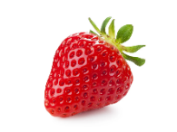  Shepherd’s Pie (2,7)  Homemade Bread  Peas and Corn | Roast Turkey with Sage & Onion Stuffing (2)  Mashed Potatoes,  Carrots & Green Beans | Beef Lasagne (2,7)  Garlic Bread  Fresh salad | Breaded Fish  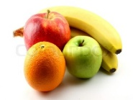  Cake (2,5)  Peas  Chips
Veggie Option |  | Vegetable Pie (2) | Bean Enchilada (4,7) | Vegetarian Lasagne (2,7) | Veggie Cake (2,7)
Sandwich Option | Egg or Ham Sandwich on 50/50 Bread (2,4) | Ham or Cheese on Soft Roll (2,7) | Turkey or Cheese on Soft Roll (2,7) | Ham or Cheese Wrap (2,5,7) | Tuna or Cheese Sandwich on 50/50 Bread (2,5)
Jacket Potato | Baked Beans, Tuna Mayo (4,5) or Cheese (7) | Baked Beans, Tuna Mayo (4,5) or Cheese (7) | Baked Beans, Tuna Mayo (4,5) or Cheese (7) | Baked Beans, Tuna Mayo (4,5) or Cheese (7) | Baked Beans, Tuna Mayo (4,5) or Cheese (7)
Dessert | Strawberry Mousse (7) | Chocolate Sponge (2,4,7) | Peach Crumble with Custard (2,7) | Ice Bun (2) | Shortbread (2)


The Sandwich options are served with Fruit, Vegetable sticks and Desserts of the day. Fresh Fruit Daily.
Allergen Key: 1) Celery, 2) Cereal Containing Gluten, 3) Crustaceans, 4) Eggs, 5) Fish, 6) Lupin, 7) Milk, 8) Mollusc, 9) Mustard, 10) Nuts, 11) Peanuts, 12) Sesame seeds, 13) Soya, 14) Sulphur Dioxide, 15) Barley, 16) Oats.

