 | Week I | Week 2 | Week 3
Mon | Rice cakes with low fat cream cheese.  Yogurt and a selection of fruits.   | Toasted pitta with Tuna or Cheese.  Yogurt and a selection of fruits. | Cheesy oatcakes with cherry Tomatoes.  Selection of Fruit available.
Tues | Cheese on wholemeal wrap with  vegetable sticks and  hummus dip.  Selection of fruits available. | 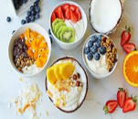 Wholegrain waffle with honey and banana. Yogurt and a selection of fruits. | Wholemeal bagels with cream cheese and Cucumber Sticks.  Selection of fruits.
Weds | Pitta bread with hummus and vegetable sticks.  Selection of fruits. | Cheese on toasted wholemeal bread.  Yogurt and a selection of fruits available. | Tuna or Cheese on wholemeal roll with  Cucumber sticks  Fresh fruit available.
Thurs | Pitta with cheese or tuna and vegetable sticks.  Yogurt and a selection of fruits available. | Pitta with cheese and vegetable sticks.  Yogurt and a selection of fruits available. 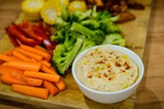 | Pitta with cheese and vegetable sticks.  Yogurt and a selection of fruits available.
Fri | Honey Sandwich or cheese on wholemeal bread.  Selection of fruits available. | A selection of fruits with Yogurt. | 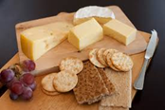  Fruit and yogurt.

After School Club Spring 2026

